**Module Name:** Login Page

**Test Case ID:** TEST1

**Webpage URL:** https://www.codecademy.com/login

**Scenario ID: TS-A**

**Scenario:** Sign up with valid credentials  
**Test Steps:**

1. Enter Username
2. Enter Password
3. Click on login

**Screenshots:**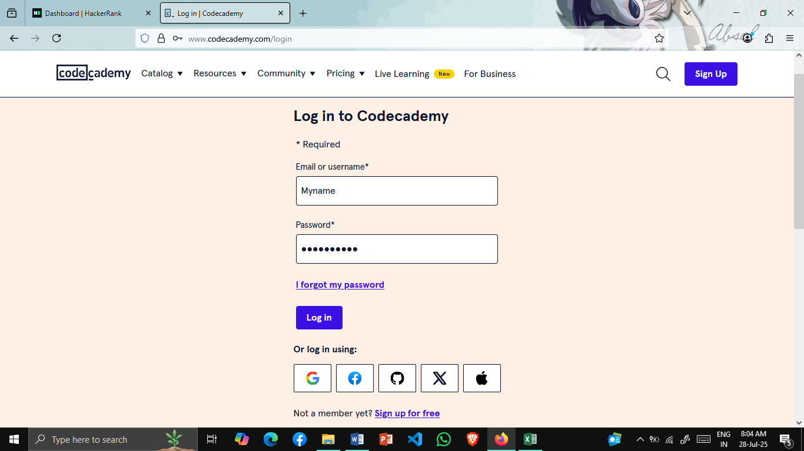

### **Scenario ID: TS-B**

**Scenario:** Sign up with invalid credential  
**Test Steps:**

1. Enter Username
2. Enter Password
3. Click on login

**Screenshots:**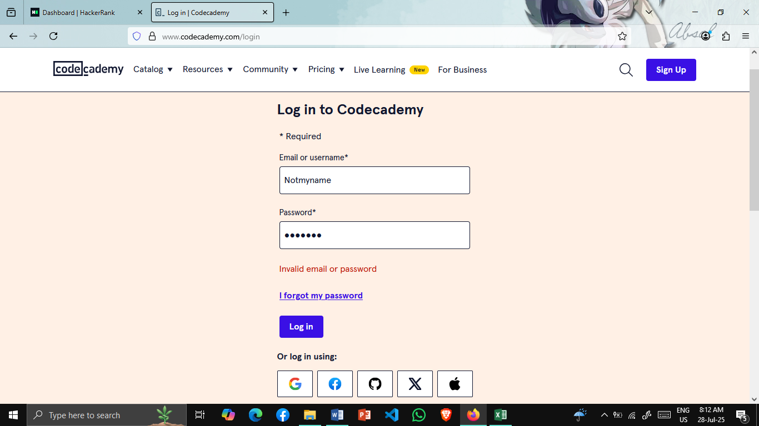

### **Scenario ID: TS-C**

**Scenario:** Checking forgot password option  
**Test Steps:**

* 1. Click on I forgot my password
  2. Please enter your email
  3. Click on Request Password Reset

**Screenshots:**



### 

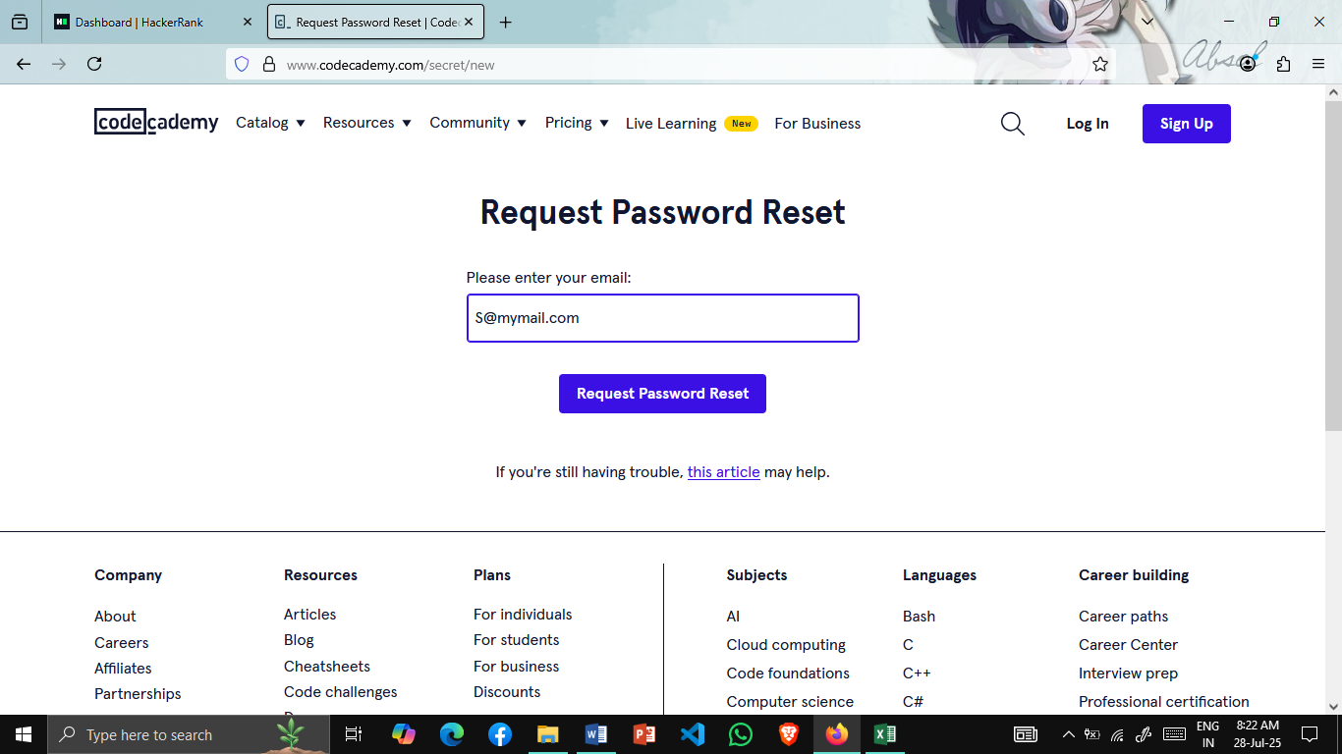



### **Scenario ID: TS-D**

**Scenario:** Checking login using other media  
**Test Steps:**

1. Click on your media logo
2. Select Your Account

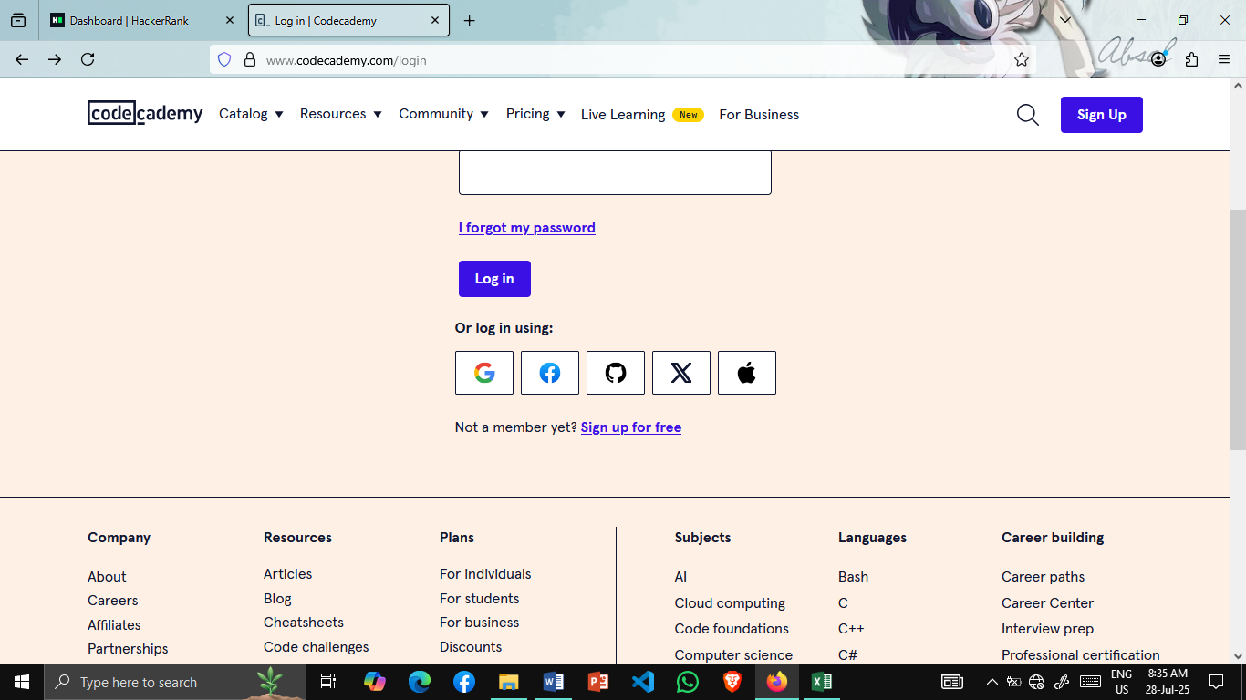**Screenshots:**